UNIT :4 PERFORMANCE MEASUREMENT AND MANAGEMENT
INTRODUCTION:
In this discussion paper we will discuss about meaning, objectives, benefits for balanced score card and will design the balanced score card for Antony’s Orchard.
NEED AND IMPORTANCE OF BALANCED SCORE CARD:
As we understand that Balanced score card is a strategic management tool, but over a period of time it evolved as more comprehensive tool and it works as a bridge between Company’s vision and mission and strategy to achieve the desired goals. It was first presented in 1992 by Kaplan and Norton. Over a period of time its recognition has changed from performance management system to highly recognised tool for integrated strategic planning and management. In our past we have used financial metrics for performance evaluation and goal settings but now it’s time to adopt advanced version and shift towards more integrated approach which can align all major key factors of operations, sales, finance & people. Balanced score card is a proven tool to accomplish these objectives hence below I will discuss about some key features of balanced score card and then set up the balanced score card for our business.
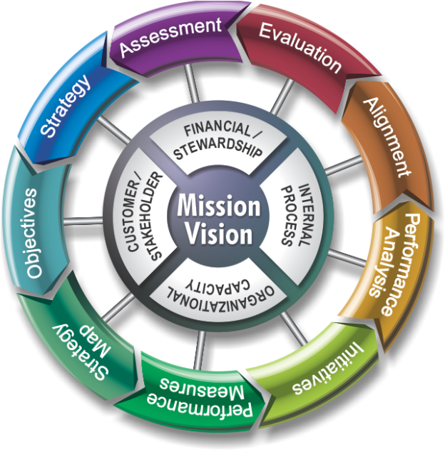

PILLARS FOR BALANCED SCORE CARD:
As we can see in the images as given above the vision and mission of the Company translate into four perspectives:
- Financial/ stewardship:

This will cover the value creation for our stakeholders. Eventually everything translates into financials therefore it’s reflective of our performance against other measures. It can be measured by ROA, ROCE, sales growth, cash flow & EVA.

- Internal business process:

Under this category focus is on improvement in productivity, quality and efficiency. It can be measured by performance benchmarking against our targets for no of innovation achieved to meet customer demand and exceed customer expectations, quality parameters, cycle time reduction, cost efficiency, sound distribution & post sales services.

- Organizational capacity:

Under this category we focus on building our employee strengths. Efforts are directed to achieve the level of satisfaction for employees and to keep their morale and motivation level at high. It can be measured by retention ratio, training, capacity building, skills enhancement, motivational level, and documentation and availability of critical information for front line employees.

- Customer/stakeholders;

Here focus point is our customer or prospective customer. It is pertinent to note here that starting point for everything is customer and our internal process/finance depends on customer order. Accordingly to make sure that we have the strong beginning point we should understand the customer requirements clearly and should build our systems and capabilities in a manner so as to meet those. Measurement criteria can be Market share growth, customer satisfaction level, retention and new order from existing customer, profitability etc.

BENEFITS:

There are many success stories which were made possible with the help of implementation of balanced score card, below I can summarize the proven major benefits of balanced score card:
- It’s a management tool and integrates all the aspects of business thereby consolidate the efforts and take those to same direction.
- It’s not a control tool and it enables executives to align their efforts with the strategic movements of the Company.
- Starting from top strategic objectives these objectives are further translated into smaller objectives at each level of operation.
- Here performance measurement is linked and integrated with overall strategic objectives of the Company
METRICS FOR BALANCED SCORE CARD:
Considering our organization goals, vision & strategic movements, I propose below metrics for our balanced score card and also seek comments/ feedbacks from all the departmental heads and their respective teams. We can adopt these measures once we all are agreed and reach on the same page for the purpose of implementing balanced score card. Purpose of balanced score card can be achieved only if we work with a joint & collaborative approach, hence executives / heads should discuss these with other down the line people and take their suggestion / feedback also into consideration for finalizing the measures of our balanced score card.

- Financial:
Sales growth = 23% (CAGR)
Contribution margin ratio = 18%
ROCE = 20%
ROA = 16%
Free cash flow = 10% increase from last year

- Internal business process:
Quality = Rejection less than 2%
Wastage control = 10% reduction in wastage and crop damage
Cost efficiencies = 5% reduction in all cost except government levies and taxes
Post sales services = Resolution of 90% complaint received in max 10 days time

- Learning and growth:
Attrition ratio = <5%
Training = Minimum 2 training program for all employees
Team building = Monthly in house meeting of key managers and 2 outdoor meeting
Skill/motivation = Rotation of jobs in every 2 years, employee feedback system
Critical information = documentation of all key process

- Customer;
Market share = 5% increase
Customer relation = Monthly meeting with key customers and resolution of problems
Delivery = 100% on time
Retention = continuation of 95% customers with the company
Workings for financial targets:
Sales growth rate = (25 / 11) ^ (1 / 4) - 1 = 23%
ROA = (2587002 – 1405000) / 7560170 = 15.63 % OR 16%
ROCE = (2587002 – 1405000) / (2150000 + 3935170) = 19.42 % OR 20%
These objectives also need to be break down further by the task leader with team involvement. So as to implement these metrics into day to day activities and get the whole hearted involvement of all the employees and stakeholders and enable constant measurement. Measurement is a means of communication and not only control tool. It is said that things which cannot be measured cannot achieved. Here it will be also of worth to reiterate that there must be cause and effect relationship between strategic initiatives and objectives / measures in our balanced score card. Strengths areas like good customer base, location, distribution system etc should be given attention for continuation and weaker areas like high attrition ratio, higher fixed cost, higher cycle time should be our focus point of improvement.
Our balanced score card will be based on clear strategy and then this score card should be the originator of strategic initiatives which will turn out to be personal objectives. Eventually we should be achieving the below strategic outcomes:
- Satisfied shareholders
- Delighted customers
- Efficient and effective process
- Motivated and skilled workforce

