CQF Module 4 Examination

dW is the usual increment of a Brownian motion.

fi. Caplet Ø2. HJM model evolves the forward curve using the system of same-form SDEs. To ob- tain an expectation of LIBOR rate in the future select the rate from corresponding tenor column
r = fs‡fi — fs of the HJM output. Gonvert to the simple annualised rate using J = m .efƒm — fi.
where m is compounding frequency per year.

Forward LIBOR J(t; fs, fs‡fi) expires at fs when the rate becomes a LIBOR fix and matures at fs‡fi
when the cashflow is paid.

Design and code the Monte Garlo pricing of a floorlet optiom written on 6M LIBOR J(O; O.5, fi), DFOIS(O, fi) × r × max (K — J, O)
with parameters K = 6%, r as follows from the task (Notional is absent). To obtain the discounting curve, assume no traded OIS instruments available but the LIBOR-OIS spread is 8Obp‹. Subtract that constant spread from each simulated forward curve to obtain discounting curve and DFOIS.

Use Black formulae to obtain option volatility. The solution is only possible numerically, ether by setting up the Solver problem on a spreadsheet or coding/using a root-finding procedure.
Floorlet = DFOIS × r × [K N(—dX) — J N(—dfi)]

lu(J/K) T O.5oXf

dfi,X =
o,f

- Refer to HJM Modet MG.stsm spreadsheet on how to evolve the forward curve. Æecode the SDE simulation in the suitable environment using the same volatility functions – that is, without recalibration.
- Gonvergence diagrams must be provided together with a brief error analysis. Gonsider using low-discrepancy sequences of random numbers.
- Vary the strike K and graphically present the model-dependent volatility skew (if any).
Example of an option payoff calculation is given on Gaplet tab in HJM Modet MG.stsm. Use Python, VBA, G‡‡ or other suitable environment. It is part of the exam task to interpret these instructions and choose correct rate and DF from the simulated curves output.

[35 Marks]
fi

£. We wish to find the approximate value of a cashflow for a floorlet on the one month LIBOR, when using the Vasicek model. Show that this is given by

max .rf — r — fi (y — çr) , O. ,
X4

where rf is the floor rate and r the spot rate. [15 Marks] Vou MUST start by comsiderimg the yield curve power series expressiom givem im the calibratiom amd data amalysis lecture. FULL workimg should be givem for the series expamsiom, or you will lose credit.

3. Gonsider the following interest rate data
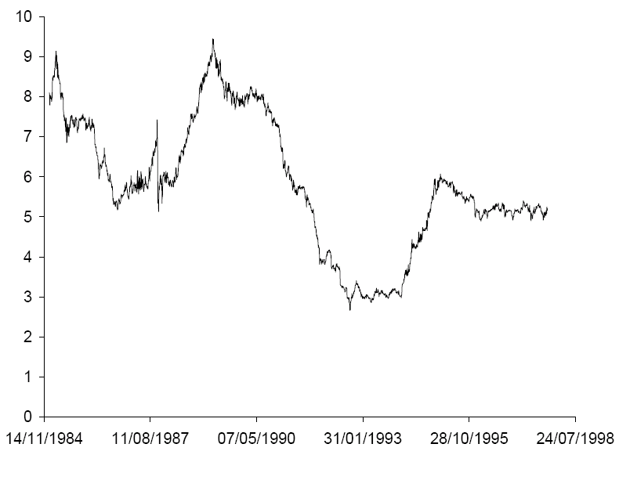
for which we wish to obtain a model of the form

dr = u (r) ‡ rrØ dE.

Outline a method for doing this. Your account should be no longer than two and a half sides of A4 paper and include details of: capturing the volatility structure u (r); functional form of the drift u (r) ; slope of the yield curve to calculate the market price of risk Z (r) .[20 Marks]

