Academic Writing with Qualitative and Quantitative Methodology
Qualitative Research Methodology or Quantitative Research Methodology?

This is the most complicated and complex domain of understanding for any researcher. Selection of the correct methodology for any academic research writing work is very important. Since, it is through the application of right and relevant methodology that a research work can prove its authenticity, the selection of the same remains very significant. Unfortunately, there is the need of voracious reading and constant stress of analysis for attainment the right concepts of these methodological structures. In the process of knowing the right approach of adopting either qualitative or quantitative methodology; the research must have the basic ways of understanding these formulations (see Table 1 for details.

Table 1 Comparison between Qualitative and Quantitative Analyses
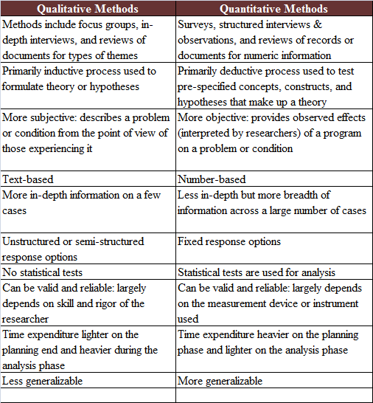

Source: ORAU (2016)

From the comparative analysis mentioned in Table 1, it is clear that quantitative methodology is subject to remain expressive through numerical derivations or quantifiers. This can be well exemplified quantitative data that are noted in terms of achievement tests, study hours, subject weightage, etc. data attained through quantitative methodology are either from internal, ordinal, or ratio scales, which can be lend to most accurate form of statistical calculation.
On the other hand, qualitative data are never illustrated through any numerical representations. The information collected through qualitative methodology are liable to represent the ranges of nominal scales, especially in terms of gender, age, socio-economic lifestyles, religious believes, cultural preferences, etc.
The only common purpose of these methodological approaches is in gaining valid and authentic data, which can lead to the determined research objectives. Statistical analysis of quantitative data or the proceedings of rigorous assessment of qualitative methodology are the means of gaining authentic research works, hence the target of a higher education degree. Comprehensive understanding of these methodologies and appropriate selection of the right research methodology, can offer higher grades to the researcher. Professional academic assistance in this frontier is the best option for attaining the desired academic goal.

Source:
ORAU (2016) Differences Between Qualitative and Quantitative Research Methods. Oak Ridge Institute for Science and Education. Retrieved on 20th July 2017, from https://www.orau.gov/cdcynergy/soc2web/Content/phase05/phase05_step03_deeper_qualitative_and_quantitative.htm

