Tourism Development Plan Bhutan

Table of Contents
1. Introduction 2
2. Significance of Tourism Planning and Development 2
3. Choice of Tourism Destination 4
3. Sustainable Tourism Development in Bhutan 5
3.1 Factors that can affect Future Sustainability and Growth of Tourism in Bhutan 5
3.2 Steps for Achieving Sustainable Tourism Development in Bhutan 7
4. Conclusion 10
References 12

1. Introduction
The term tourism can be significantly defined or expressed as the cultural, economic and social phenomenon that significantly entails the overall movement of people of individuals from one place to another which is outside their habitual environment. With the advent of globalization, it has now become a necessity to effectively manage and develop tourism. The overall management and development is required to be done in a well integrated, controlled and sustainable way which can be said to be based upon a sound planning and strategy. This overall approach can significantly result in generation of substantial benefits regarding the economy of a specific area without any severe social problems or environmental damages. Tourism planning can be seen to prevail at different levels of growth and development such as national, regional and international (Smith, 2003). The regional and national level of tourism planning and development significantly emphasizes on laying out the necessary foundation for development of tourism in a specific country or nation and its subsequent regions. The overall process can be considered to establish the institutional and physical structures, polices and standards for the purpose of enabling the development of tourism in a logical manner. In addition, it also makes some significant contribution towards continuous improvement in the tourism management system which is necessary for success and growth of tourism in the long term. The overall report will make an extensive analysis of a sustainable tourism development planning and strategy for the chosen tourism location of Bhutan (Parida, 2008). The overall report will significantly emphasize on the significance of tourism planning, development and strategy and will showcase a well structured sustainable tourism development strategy for the chosen location of Bhutan.

2. Significance of Tourism Planning and Development
Tourism planning and strategies are significantly necessary for the purpose of achieving a successful tourism management and development. It has been observed that a planned approach towards tourism development can bring about substantial benefits without causing any major problems and can maintain or monitor the contented tourist markets. Regions or places which have tried to develop tourism without any significant tourism plan or strategy are seen to be facing various different kinds of social as well as environmental problems or issues. Such kind of circumstances can be said to be detrimental to the respective residents and are viewed as unpleasant by the tourist. This overall situation can ultimately lead to decreased economic benefits and other marketing difficulties. The tourism locations without any controlled or planned tourism approach fails to compete with the tourist destinations that incorporate proper tourism planning. Such destinations can be easily redeveloped by incorporation of a well planned strategy or approach, but the overall process is time consuming and requires substantial financial investment (Richards, 2000). Tourism can be considered to be a complicated activity or process that significantly overlaps with various different sections or sectors of economy and society. Without implementation of proper planning and strategy it may result in unwanted or unexpected negative impacts. In many nations or countries the concept of tourism is still relatively new. They significantly lack the necessary experience for proper and proficient development of tourism. An effective tourism planning can significantly provide the much needed guidance for tourism development to the countries or nations lacking in tourism. Tourism planning and strategy can provide some substantial benefits to the tourism destinations or places. The benefits and advantages can be significantly listed as follows:
- Establishment of the tourism development policies and objectives.
- Developing tourism in such a manner that the overall cultural as well as the natural resources are significantly conserved and maintained for future use.
- Integration of tourism into the development patterns and policies of the respective region or country and establishment of valuable linkage between economic sectors and tourism.
- Facilitating the decision making on development of tourism by private as well public sectors (Pineda and Brebbia, 2012).
- Facilitating the overall coordinated development of different tourism sector elements. These elements significantly include inter-relating of tourist activities, attractions, services and other tourist facilities.
- Significant balancing and optimization of the environmental, social and economic benefits and advantages of tourism and facilitating the equitable distribution of such benefits and advantage to the overall society (Pineda and Brebbia, 2010).
- Establishment of the various standards and guidelines for the preparation of detailed plans and processes relating to specific or particular areas of tourism development.
- Provision of the model or framework for the purpose of efficient coordination of private as well as public sector investment and efforts for tourism development.

3. Choice of Tourism Destination
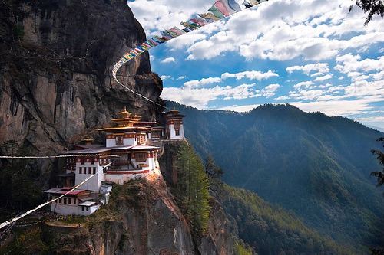
The tourism destination chosen for this particular report is Bhutan. Officially known by the name of Kingdom Of Bhutan, Bhutan is located in the eastern side of Himalayas. In the north the country is bordered by China and is bordered by India to the east, west and south (Cooper, 2001). The country of Bhutan is widely famous with international tourist for its picturesque beauty, rich traditional culture and heritage and spirituality and wellness. The country of Bhutan provides the tourists with a wide range of options starting from trekking, adventure sports, observation the scenic beauty of nature to enjoying and experiencing their colorful festivals, rich cultural heritage, highly delicious foods and spirituality. Each and every year a significant number of tourists visit Bhutan for their tours and holidays. Bhutan has a significant number of tourist attractions. Some o f them includes places like Paro, Thimpu, Punka, Haa Valley and many others. The country has some beautiful and ancient monasteries and temples in the world with the most famous being the Paro Taktsang or the tiger nest monastery situated in a cliff of the Paro valley. The monastery is said to be one of the most ancient and sacred monastery in the world. Over the years the rate of tourists visiting Bhutan has substantially increased to a great extent. With such a heavy traffic inflow of tourists it has now become a necessity of Bhutan to implement proficient plans and strategies for development of sustainable tourism. Sustainable tourism will not only enable the respective country to manage its tourism in the most efficient manner but at the same time will enable Bhutan to preserve and minimize the ill or harmful effects on the environment and the society. The report will make an in depth analysis and assessment of the strategies, approaches and planning that are needed to be implemented for promotion of sustainable tourism development in Bhutan (Solway, 2010).

3. Sustainable Tourism Development in Bhutan
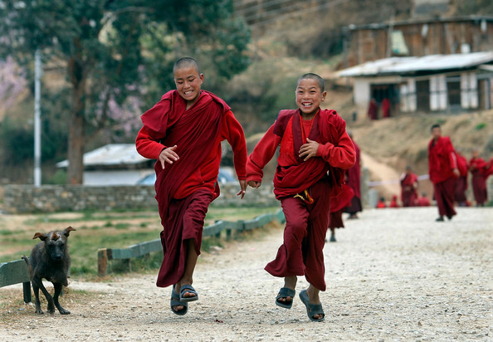
Bhutan can be considered to be among the few nations which have taken significant initiatives towards managing a controlled tourism for the purpose of ensuring the overall growth and sustainability of the tourism industry in the extended future run. The initiatives taken by Bhutan have significantly contributed towards government revenues and foreign exchanges and earnings which have extensively generated employment, income and regional developments to a great extent. The overall tourism industry in Bhutan has substantially generated rightful opportunities for the development and growth of various private as well as locally owned enterprises. Over the years, Bhutan has used its tourism as a significant mechanism for the purpose of publicizing the nation’s rich, colorful and vibrant cultural traditions and heritage to the world. The tourism in Bhutan has an immense potential with significant comparative advantages or benefits in various different sectors or areas for the purpose of ensuring diversification and all around economic growth and development. Eco tourism, cultural tourism, sports and adventure tourism which are based upon the picturesque natural and scenic beauty of the respective nation can be efficiently said to offer substantial opportunities for future development and growth of the tourism industry. In addition, it can b said that the tourism industry in Bhutan has generated ample amount of income and employment for their people which has resulted in the growth and development of the overall tourism industry (Pineda and Brebbia, 2008).

3.1 Factors that can affect Future Sustainability and Growth of Tourism in Bhutan
There are some major problems or issued associated with Bhutan tourism that have the potential of having a substantial negative impact or influence on the sustainability and future growth of tourism industry of Bhutan. The problems or factors can be extensively summarized as follows:
- Seasonality: The arrival of tourists in Bhutan can be said to be subjected to seasonality. There is a heavy inflow tourist in Bhutan for the month of March to April and October to November. The above mentioned months are ideal for tourists to enjoy their stay in Bhutan and experience trekking, adventure tourism and cultural festivals. However, the months of January to February and June to July exhibits lowest tourists activities as the weather is not suitable for trekking and adventure sports and there are no significant religious and cultural festivals taking place in the nation. Thus it can be said that the seasonal nature of tourism results in uneven distribution of tourists which significantly adds pressure on the overall infrastructure during peak seasons. During the peak seasons, the tourism industry in Bhutan faces the significant problem of inadequate facilities and low quality of facilities and services offered to the tourists.
- Regional Imbalance: Another issue that has the potential to affect the overall sustainability and growth of Bhutan tourism is regional imbalance.
- Improper Diversification of Products: Tourism in Bhutan can be said to be significantly limited to sightseers, cultural tourists. It is significantly essential for the nation of Bhutan to substantially develop other tourism areas and interests such as adventure tourism, sports and nature tourism (Page and Connell, 2008).
- Local Community Involvement: It is essential for Bhutan to involve the local communities in the tourism industry for the purpose of achieving a significantly high growth and development of the overall tourism industry.
- Weak Institutional Structure: The tourism industry in Bhutan significantly lacks finance and manpower which is essential for the future sustainability, growth and development of the tourism industry. Bhutan lacks qualified and skilled manpower specifically in the departments of management and entrepreneur.
- Lack of tourism research foundations: It is needed for Bhutan tourism to have proper process and system of surveys, research, statistics, feedback and data collection for the purpose of achieving a high growth and sustainability of the tourism industry (Pearce, 2009).
- Improper Pricing Integrity: In spite of the governmental policies allowing high profitability margin for the tourism operators, the increased competitiveness in the tourism industry market in Bhutan has substantially lead to undesirable results. This has resulted in deterioration of services and qualities that are offered to the tourists and visitors which can have a substantial negative impact on the overall growth and development of tourism in the nation of Bhutan.

3.2 Steps for Achieving Sustainable Tourism Development in Bhutan
Bhutan has a well established model or framework for the purpose of tourism development. The nation has clear, well planned and structured policies, an expanding and developing private sector, experienced, skilled and qualified personnel, well developed contacts and marketing channels. Bhutan has significantly achieved privatization of the tourism industry, development of the travel and tourism sector. This overall process has enabled Bhutan to establish itself as a distinctive, exclusive tourism and travel destination (Moscardo, 2008). The future growth and development of tourism in Bhutan now significantly involves a significant process and system of refinement and attempts have been made for the purpose of mitigation of any significant negative influences or impacts on the culture and environment. In addition it is significantly essential for the tourism industry of Bhutan to substantially develop the niche markets, including that of eco tourism, which can substantially offer some major benefits and growth potential for the travel and tourism industry sector of the country of Bhutan by increasing the overall participation and involvement of the various local communities and groups in tourism related operations and activities.
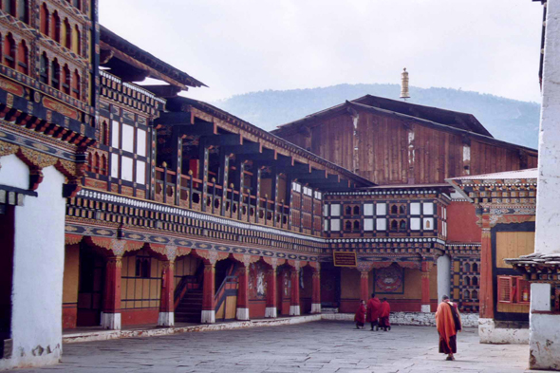
The future growth and development of travel and tourism in Bhutan needs to be guided and nurtured by the idea or concept of a high value tourism. It should significantly include a constructive and well defined, effective and efficient policy towards sustainable tourism. Such a kind of policy is required to advocate control as well as caution instead of an aggressive development of tourism and is required to follow an inclusive approach rather than an approach which is sector based. It is significantly important for the policy to promote and develop the aspects of value consciousness as well as heritage conservation. The nation of Bhutan through the support of its government has significantly achieved considerable and substantial resources for tourism. This overall approach must be efficiently applied to the respective policies in regard to the development and growth of the tourism industry in the near future for the purpose of aligning the approach of sustainable tourism with the overall objectives and goals of cultural and environmental preservation (Keyser, 2002). A well defined, planned and structured policy will significantly enable the periodic monitoring, measurement and evaluation of sustainable tourism development in Bhutan by mitigation of the negative influences, impacts and ill effects of tourism. Since the concept of tourism significantly involves a wide range and dimension of economic as well as social operations and activities which are by nature multi sectored, such a well crafted and defined policy must essential include and incorporate various ministerial committees for the purpose of facilitating proficient coordination and communication between various agencies, ministries and the overall industry. The rich and vibrant culture, tradition and religion along with a pristine environment and atmosphere have made Bhutan a highly popular tourist destination. Thus it is necessary for the country of Bhutan to implement a well defined policy of sustainable tourism that can effectively promote and ensure such values which can turn is necessary for the preservation of its rich cultural and natural heritage.
It is substantially important for Bhutan to address the following mentioned issues for the purpose of ensuring and developing of a sustainable tourism development and growth in Bhutan:
- Organizational Development: It is significantly essential for Bhutan to have well developed and manufacturing organizational bodies or agencies for the purpose of maintain and monitor the growth and development of sustainable tourism in the respective nation or country. In this context, it can be widely said that Bhutan needs to develop and strengthen the overall capacity and functionality of their Tourism Department and promoting an effective coordination and communication of the department with that of the private sector organizations and agencies (Harris and Williams, 2002).
- Product Growth and Development: It is significantly essential for Bhutan to significantly improve and enhance the overall quality of services and other facilities offered to the tourists. This overall process will not only enable the development and enrich of the product, but at the same time will make significant contributions towards a greater satisfaction and expectation level of the tourists or visitors. This overall process will make significant contributions towards the overall sustainability of tourism in Bhutan. This will have a significant positive impact on the overall economy, culture and environment which in turn can be said to be significantly essential for the purpose of reducing the tourism seasonality and spreading of tourism related activities, operations and benefits to different regions across the country. In addition, it is essential for Bhutan to promote the growth and development of niche and high value market segments such as photography, ornithology, zoology, rafting, botany and others. In the context of product development it can be effectively considered that Bhutan must substantially emphasize on system classification for the purpose of tourism related facilities and minimum standards specification (George and Reid, 2009).
- Marketing Strategies: It is significantly necessary for the Bhutan government to develop and implement proficient and well developed marketing strategies for the purpose of development and promotion of sustainable tourism in the nation. For this purpose it is essential to collect as well as process complete and detailed market information and make an in depth analysis of the overall market behavior and characteristics. This overall process will effectively and efficiently facilitate the development of future plans and policies. In addition, it can also be said that the overall development and growth and new tourism products, services and facilities significantly needs and requires effective and efficient initiatives and measures of joint marketing along with combined private as well as public resources. Through effective marketing strategies and approaches it is possible for Bhutan to effectively promote their sustainable tourism and set a global footprint as one of the most popular international travel and tourism destination.
- Development of Human Resource: Human resource can be considered to be an essential aspect of sustainable tourism development in Bhutan. It is significantly essential for Bhutan to increase and maintain their overall manpower through continuous training and development. In this context, it can be said that a highly experienced, skilled and knowledgeable manpower will enable Bhutan to make substantial progress towards development of a sustainable tourism development in the country (Burkart, 2007).
If Bhutan is successful in proficient planning as well as management of the overall tourism industry, and effectively monitor and control the overall inputs, the travel and tourism industry can achieve a significant economic perspective or status without making any significant harm or damage to the overall environmental as well as cultural aspects of the nation or country. Thus it is essential for the Bhutan government to address the above mentioned issues for facilitating the growth and development of a sustainable tourism industry in Bhutan. In addition to addressing the above mentioned key elementary issues the following listed initiatives can be undertaken for promotion and facilitation of sustainable tourism in Bhutan:
- Building up resources for financing the overall development and growth of tourism industry (Brebbia, 2006).
- Drafting of future plans and policies related to the tourism industry.
- Formation of an effective and efficient industry association for the purpose of promoting, assisting and encouraging the growth and development of sustainable tourism in Bhutan.

4. Conclusion
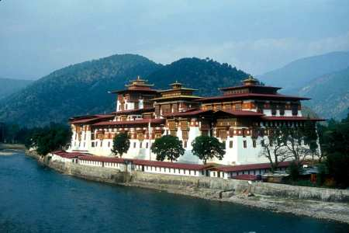
The location of Bhutan has made the country widely popular among the travelers and tourists. The nation of Bhutan effectively and efficiently preserves its natural as well as cultural environment which has enabled the respective nation to achieve a high growth and success in the field of travel and tourism industry (Aronsson, 2000). The growth and development of the tourism industry in Bhutan has provided some substantial benefits to its residents in terms of economic opportunities. But however with the growth and development of the tourism industry, the nation of Bhutan needs to implement certain approaches, strategies and measures for the purpose of conserving their rich and vibrant cultural heritage, tradition and highly picturesque and natural environment. Thus it is necessary for the nation of Bhutan to promote sustainable tourism which can significantly enhance the overall growth, development and sustainability of the tourism industry in Bhutan without having any significant negative or adverse impacts or influences on its environment and culture (Swarbrooke, 2009). The overall report has significantly addressed the key issues and has evaluated the steps and measures that can be incorporated by Bhutan for the development and growth of a sustainable tourism.

References
- Aronsson, L. (2000). The development of sustainable tourism. London: Continuum.
- Brebbia, C. and Pineda, F. (2006). Sustainable tourism II. Southampton: WIT.
- Burkart, A. and Medlik, S. (2007). Historical development of tourism. Aix-en-Provence, France: Centre des Hautes Etudes Touristiques.
- Cooper, R. (2001). Bhutan. New York: Marshall Cavendish.
- Dept, I. (2014). Bhutan. Washington: International Monetary Fund.
- George, E., Mair, H. and Reid, D. (2009). Rural tourism development. Bristol, UK: Channel View Publications.
- Harris, R., Griffin, T. and Williams, P. (2002). Sustainable tourism. Oxford: Butterworth-Heinemann.
- Hinch, T. and Higham, J. (2004). Sport tourism development. Clevedon [England]: Channel Veiw Publications.
- Keyser, H. (2002). Tourism development. Cape Town: Oxford University Press.
- Moscardo, G. (2008). Building community capacity for tourism development. Wallingford, UK: CABI.
- Page, S. and Connell, J. (2008). Sustainable tourism. London: Routledge.
- Pearce, D. and Butler, R. (2009). Contemporary issues in tourism development. London: Routledge.
- Pineda, F. and Brebbia, C. (2004). Sustainable tourism. Southampton: WIT Press.
- Pineda, F. and Brebbia, C. (2008). Sustainable tourism III. Southampton: WIT Press.
- Pineda, F. and Brebbia, C. (2010). Sustainable tourism IV. Southampton: WIT.
- Pineda, F. and Brebbia, C. (2012). Sustainable tourism V. Southampton: WIT Press.
- Richards, G. and Hall, D. (2000). Tourism and sustainable community development. London: Routledge.
- S, S., Mishra, S. and Parida, B. (2008). Tourism development revisited. New Delhi, IN: Response Books.
- Smith, M. and Duffy, R. (2003). The ethics of tourism development. London: Routledge.
- Solway, A. (2010). Sustainable tourism. Mankato, Minn.: Arcturus Pub.
- Swarbrooke, J. (2009). Sustainable tourism management. Wallingford, Oxon, UK: CABI Pub.

